TOP – BOTTOM FULL HISTORY OF TONOMETER – MEASURING IOP

CREATED BY –
SANJAI PRASATH M

Introduction to Tonometers: History, Types, and Advancements (Up to 2025)
A tonometer is a vital diagnostic tool in ophthalmology, specifically used to measure intraocular pressure (IOP) — the fluid pressure inside the eye. Accurate IOP measurement is crucial for detecting and managing glaucoma, a leading cause of irreversible blindness worldwide. Over the years, tonometer technology has evolved significantly, improving in accuracy, portability, safety, and ease of use.
This document presents a comprehensive overview of the historical development of tonometers, from early manual techniques to the latest smart, handheld devices available in 2025. It includes the different types of tonometers, notable product names, their manufacturers, and their specific uses and benefits.
The timeline and table below highlight the key milestones in tonometer development — showcasing how each new generation addressed the limitations of previous models, whether through enhanced comfort, better portability, or affordability for use in remote and rural areas.
✅ 1. Direct Tonometers
These measure intraocular pressure (IOP) by physically contacting or flattening the cornea, giving direct pressure readings.
Type | Example Devices | Features
Applanation | Goldmann, Perkins, Tono-Vera | Flattens cornea, highly accurate
Indentation | Schiøtz Tonometer | Indents cornea with weight
Rebound | iCare, iCare HOME | Probe bounces on cornea briefly
Digital Contact | Tono-Pen | Portable, pen-shaped, digital reading

🔄 2. Indirect Tonometers
These measure IOP without touching the eye or by measuring effects related to IOP rather than pressure itself.
Type | Example Devices | Features
Non-contact (Air Puff) | Nidek NT510, TonoCare | Uses air puff, no contact or drops
Dynamic Contour | Pascal DCT | Measures corneal shape change due to IOP
Ocular Response Analyzer (ORA) | Reichert ORA | Uses air + measures corneal response
Digital Palpation | Finger method | Old method, based on "feel", no device

🧠 Simple Trick to Remember:
Direct Tonometers | Indirect Tonometers
Touch the eye 👁️ | Do not touch the eye 🌀
Physical pressure | Air, light, or corneal response
High accuracy 🎯 | Moderate to high (depends on tech)

Year | Tonometer Name/Type | Company/Inventor | Type | Description
1826 | Digital palpation | Manual method | N/A | Doctors used fingers to estimate eye pressure. Not accurate.
1862 | Schiøtz Tonometer | Hjalmar Schiøtz (Norway) | Indentation | Measured how much the cornea indents under a known weight.
1955 | Goldmann Applanation Tonometer (GAT) | Haag-Streit | Applanation | Most accurate and widely used in clinics. Needs slit-lamp and anesthesia.
1960s | Perkins Tonometer | Clement Clarke | Portable applanation | Handheld version of Goldmann; used in operating rooms.
1970s | Pneumotonometer | Reichert Technologies | Pneumatic | Uses a puff of air and measures corneal resistance.
1990s | Non-contact Air Puff Tonometers | Nidek, Topcon, Reichert | Non-contact | No eye contact; uses air puff. Fast and painless.
1997 | Tono-Pen | Reichert Inc. | Digital Applanation | Portable pen-shaped, battery-powered. Very useful in emergency settings.
2003 | iCare Tonometer | Icare Finland Oy | Rebound | No anesthesia, uses a light probe that touches the eye briefly.
2014 | iCare HOME | Icare Finland Oy | Rebound | First self-tonometry device for home monitoring of glaucoma.
2016 | ORA (Ocular Response Analyzer) | Reichert Technologies | Dynamic | Measures corneal biomechanics + IOP. More precise.
2018 | iCare IC200 | Icare Finland Oy | Rebound | More advanced for clinics, no drops, used with or without anesthetic.
2020 | TonoCare | Keeler (UK) | Handheld Air-Puff | Compact, portable, non-contact. Used in mobile eye camps.
2024-2025 | Tono-Vera | Reichert | Digital + Smart Applanation | AI-integrated, touch-screen based, high-accuracy with auto-alignment.

1826-Digital palpation (used in the 1800s) doesn’t have proper images online because it was a manual method using fingers, not a device.
🖐️ What is Digital Palpation?
- "Digital" here means finger-based, not electronic.
- Doctors would gently press on the patient's eyeball using their index fingers to feel how firm or soft the eye was.
- Based on that, they estimated intraocular pressure (IOP) — very rough and subjective.

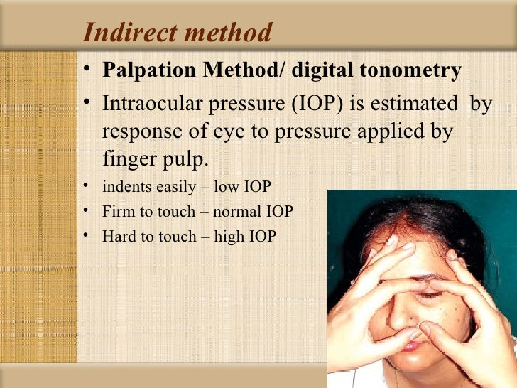

Type- Indentation
1862 | -Schiøtz Tonometer
📌 What is it?
The Schiøtz Tonometer is a mechanical instrument invented by Hjalmar Schiøtz (Norway) in 1862.
It is one of the first tonometers ever used to measure eye pressure (IOP).
🎯 Key Points:
Feature | Details
Invented by | Hjalmar Schiøtz
Year | 1862
Type | Indentation tonometer
Contact with eye? | ✅ Yes
Needs drops? | ✅ Yes (to prevent pain)
Accurate? | 🟡 Moderate (not very precise)
Still used? | Rarely — mainly in older setups or teaching

🧼 Important Notes:
- Requires anesthetic drops to numb the eye.
- Must be sterilized between patients.
- Not commonly used today — replaced by digital and non-contact devices.

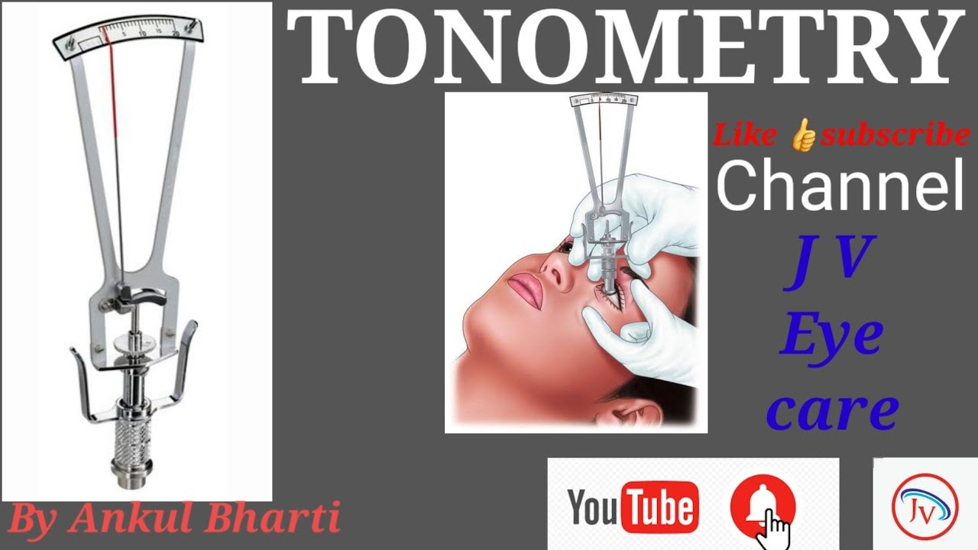

Type- Applanation
1955 | -Goldmann Applanation Tonometer (GAT)
📌 What is it?
The Goldmann Applanation Tonometer (GAT) is a very accurate instrument invented in 1955 by Hans Goldmann.
It is considered the "gold standard" for measuring eye pressure (IOP) in clinics.
The goal is to flatten (applanate) a 3.06 mm circle of the cornea.

🎯 Key Points:
Feature | Details
Invented by | Hans Goldmann
Year | 1955
Type | Applanation tonometer
Contact with eye? | ✅ Yes
Needs drops? | ✅ Yes
Accuracy | 🟢 Very high (Gold standard)
Use location | Clinics, hospitals (not handheld)

🤔 Why 3.06 mm?
Because at that exact area:
- The corneal resistance and tear surface tension balance each other out.
- So, the pressure reading becomes highly accurate.

🧼 Requirements:
- Anesthetic eye drops (to prevent pain)
- Trained professional
- Slit lamp (so it's not portable)

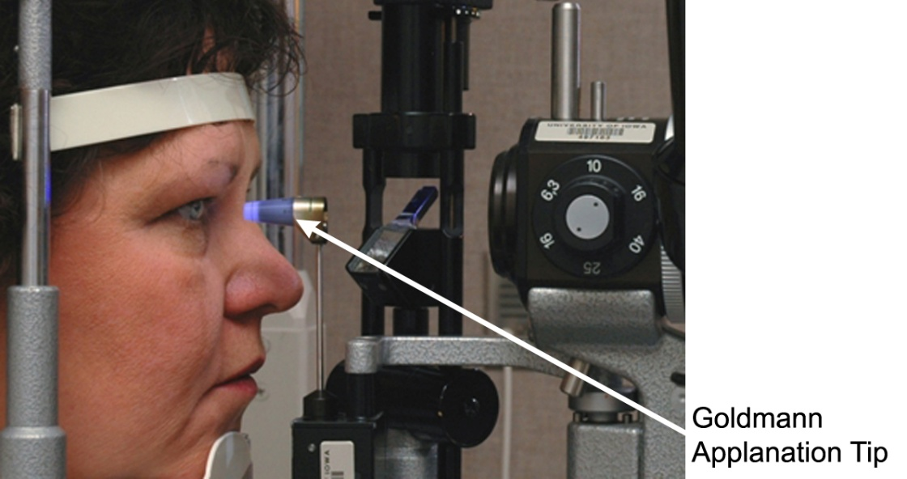

TYPE - Portable applanation
1960s- | Perkins Tonometer
🧪 Perkins Tonometer – Simple Method to Understand
📌 What is it?
The Perkins Tonometer is a portable version of the Goldmann Applanation Tonometer, developed in the 1960s by Clement Clarke International (UK).
It allows doctors to measure eye pressure (IOP) without needing a slit lamp, making it ideal for use in bedridden patients, children, and operating rooms.

⚙️ How does it work?
- Works using the applanation method (flattens part of the cornea).
- Has a small cone tip like Goldmann, which touches the eye.
- The doctor uses a blue light and fluorescein dye to see the flattened area.
- The device shows a scale reading, which gives the IOP in mmHg.
📦 It is battery-powered, handheld, and can be used with the patient lying down — unlike Goldmann which needs the patient to sit at a slit lamp.

🧼 Requirements:
- Anesthetic eye drops
- Fluorescein dye
- Cleaning/sterilization between uses

🎯 Key Points:
Feature | Details
Invented by | Clement Clarke Ltd. (UK)
Year | 1960s
Type | Applanation tonometer
Contact with eye? | ✅ Yes
Needs drops? | ✅ Yes
Accuracy | 🔵 High (almost equal to Goldmann)
Use location | Clinics, mobile screening, surgeries
Special use | Can be used for lying-down patients

🤔 In Simple Words:
The Perkins Tonometer is like a portable Goldmann tonometer that you can hold in your hand and use on patients who can’t sit upright.
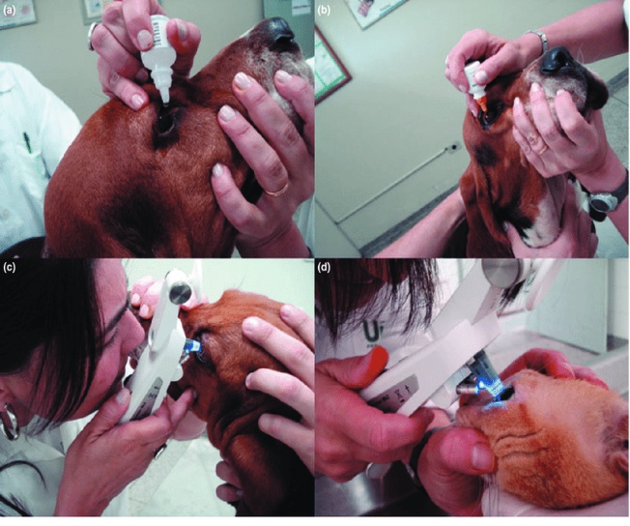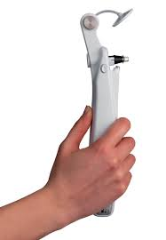

TYPE- Pneumatic
1970s | -Pneumotonometer

🧪 Pneumotonometer – Simple Method to Understand
📌 What is it?
The Pneumotonometer is a special type of contact tonometer developed in the 1970s that uses a gentle stream of air (pneumatic pressure) to measure intraocular pressure (IOP).
It was introduced by companies like Reichert Technologies (USA) and became popular for use in both humans and animals.

⚙️ How does it work?
- A tiny, soft probe gently touches the cornea.
- Inside the probe is a tiny air column.
- When the probe touches the eye, the pressure in the air column changes.
- The device measures this change and converts it into IOP value.
Unlike the air-puff tonometers, this one does touch the eye — but uses pneumatic sensing, not mechanical flattening.

🧼 Requirements:
- Anesthetic eye drops (because it's a contact method)
- Needs regular calibration for accurate results

🎯 Key Points:
Feature | Details
Introduced in | 1970s
Made by | Reichert and others
Type | Contact (pneumatic) tonometer
Touches the eye? | ✅ Yes
Needs anesthetic drops? | ✅ Yes
Measures by | Air pressure change when probe contacts cornea
Accuracy | 🔵 Moderate to high
Special use | Used in clinical and veterinary settings

🤔 In Simple Words:
The Pneumotonometer is a contact device that uses air pressure inside a probe to measure eye pressure when it touches the eye — different from air-puff, but still needs numbing drops.
